**Project Design Phase-II**

**Technology Stack (Architecture & Stack)**

|  |  |
| --- | --- |
| Date | 15 October 2022 |
| Team ID | PNT2022TMID44635 |
| Project Name | Project –Health Care Data analytics |
| Maximum Marks | 4 Marks |

**Technical Architecture:**

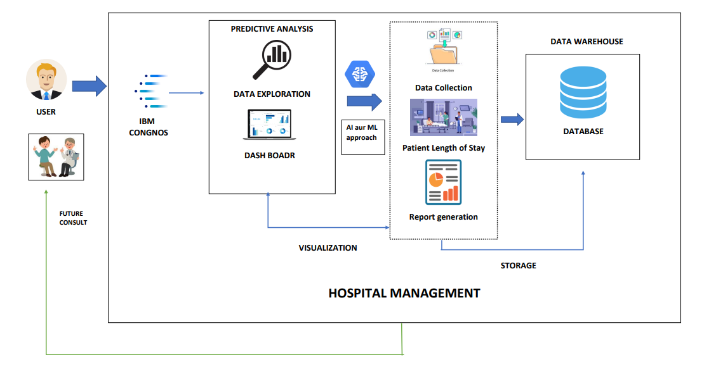

**Table-1 : Components & Technologies:**

|  |  |  |  |
| --- | --- | --- | --- |
| **S.No** | **Component** | **Description** | **Technology** |
| 1. | User Interface | All the data in Ms Excel sheet | IBM Cognative analysis |
| 2. | Application Logic-1 | Then Upload the data in IBM Watson | Ms Excel Sheet or Kaggle dataset |
| 3. | Application Logic-2 | Prepare the data | IBM Watson STT service, Kaggle data set |
| 4. | Application Logic-3 | Explore the Data | IBM Watson Assistant |
| 5. | Database | Present data | Using numpy, pandas, seaborn lib |
| 6. | Cloud Database | Database Service on Cloud | IBM DB2, IBM Cloudant etc. |
| 7. | File Storage | Dashboard | IIBM cognos |
| 8. | Infrastructure (Server / Cloud) | Application Deployment on Local System /  Cloud  Local Server Configuration:Tableu  Cloud Server Configuration : IBM CLOUD | Eda Python, using jupyter notebook anaconda software or google colab. |

**Table-2: Application Characteristics:**

|  |  |  |  |
| --- | --- | --- | --- |
| **S.No** | **Characteristics** | **Description** | **Technology** |
| 1. | Open-Source Frameworks | **Software with a source code that anyone can inspect, modify or enhance**. | **Visualization, charts, discriptive** |
| 2. | Security Implementations | Including administrative controls, physical security, logical controls, organizational | e.g. firewalls.  authentication and authorization. |
|  |  | standards | encryption. data masking |
| 3. | Scalable Architecture | **The ability of a hardware/software parallel system to exploit increasing computing resources effectively in the analysis of (very) large datasets**. | **a package delivery system** |
| 4. | Availability | **An organization ensures that all of its business-related data is available to the organization, partners, or end-users at any time of the day, whenever and wherever required**. | NoSQL Databases. Knowledge Discovery Tools. Stream Analytics.  , In-memory Data Fabric. Distributed Storage. |
| 5. | Performance | **the process of quickly examining extremely large data sets to find insights** | hadoop |